ICP 3 Screenshots

**Answer 1)**

**Code:**

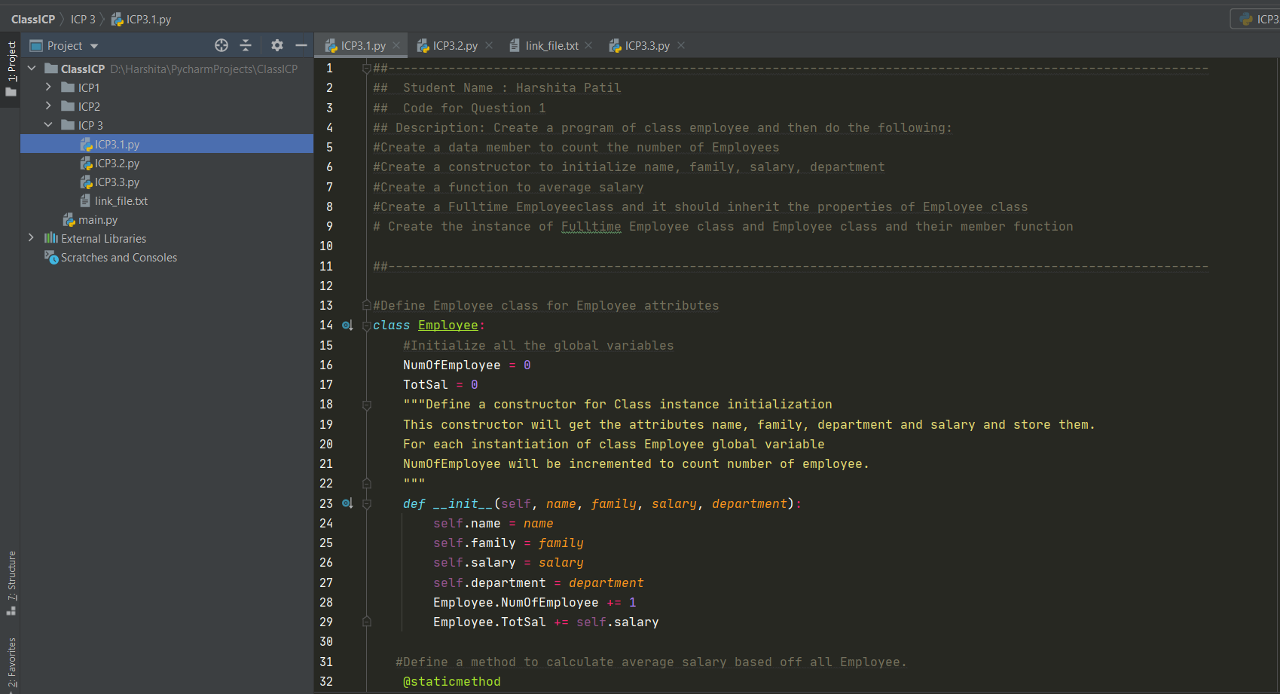

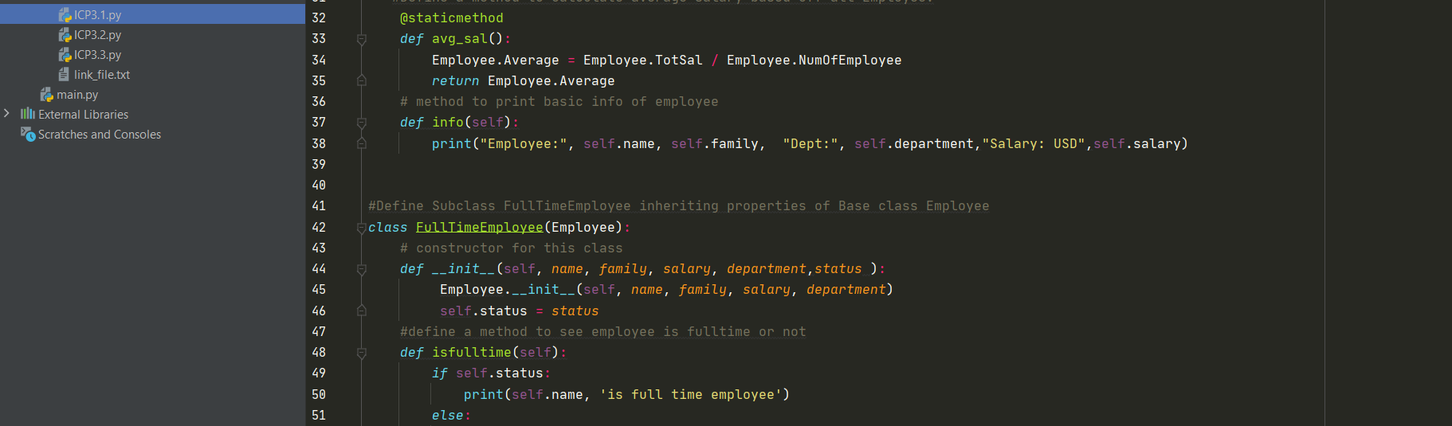

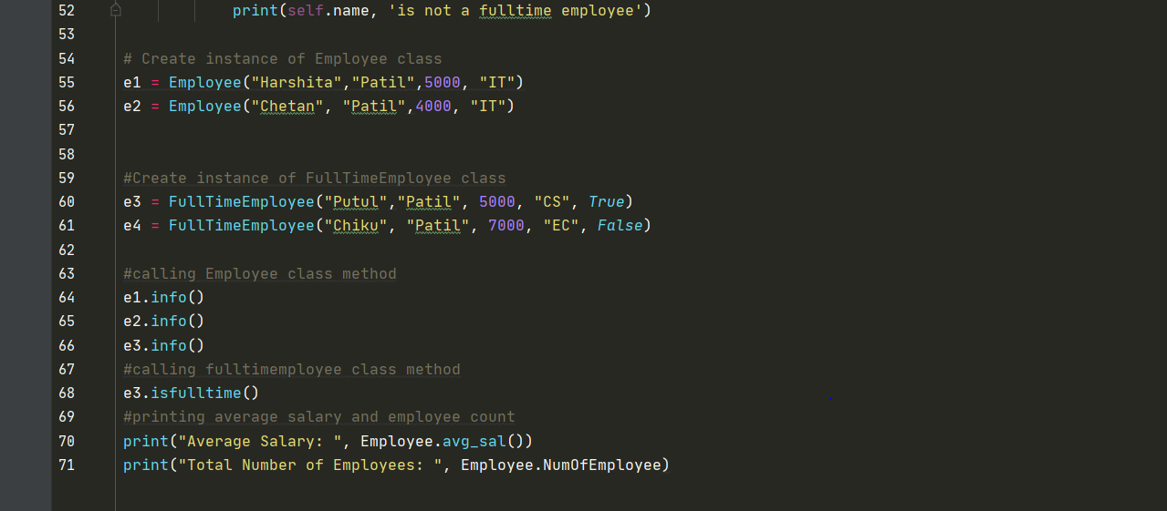

**OUTPUT: Output displays details for 3 out of 4 employees. It also displays Name of one of the Fulltime Employee. Apart from that Average Salary and total number of employees displayed.**

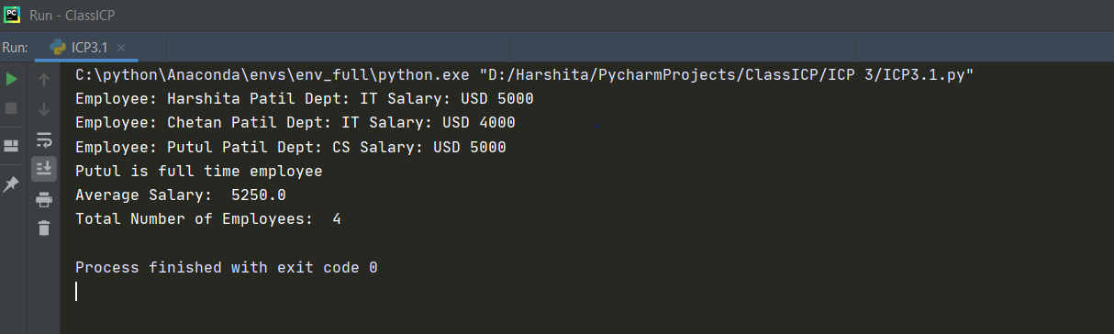

**Answer2)**

**Code:**

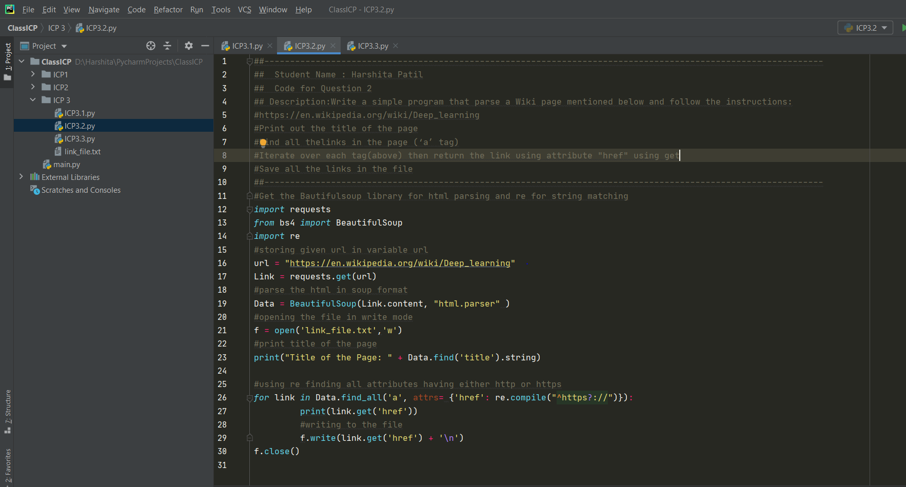

**OUTPUT: Output displays only the URL’s extracted from Wiki page.**

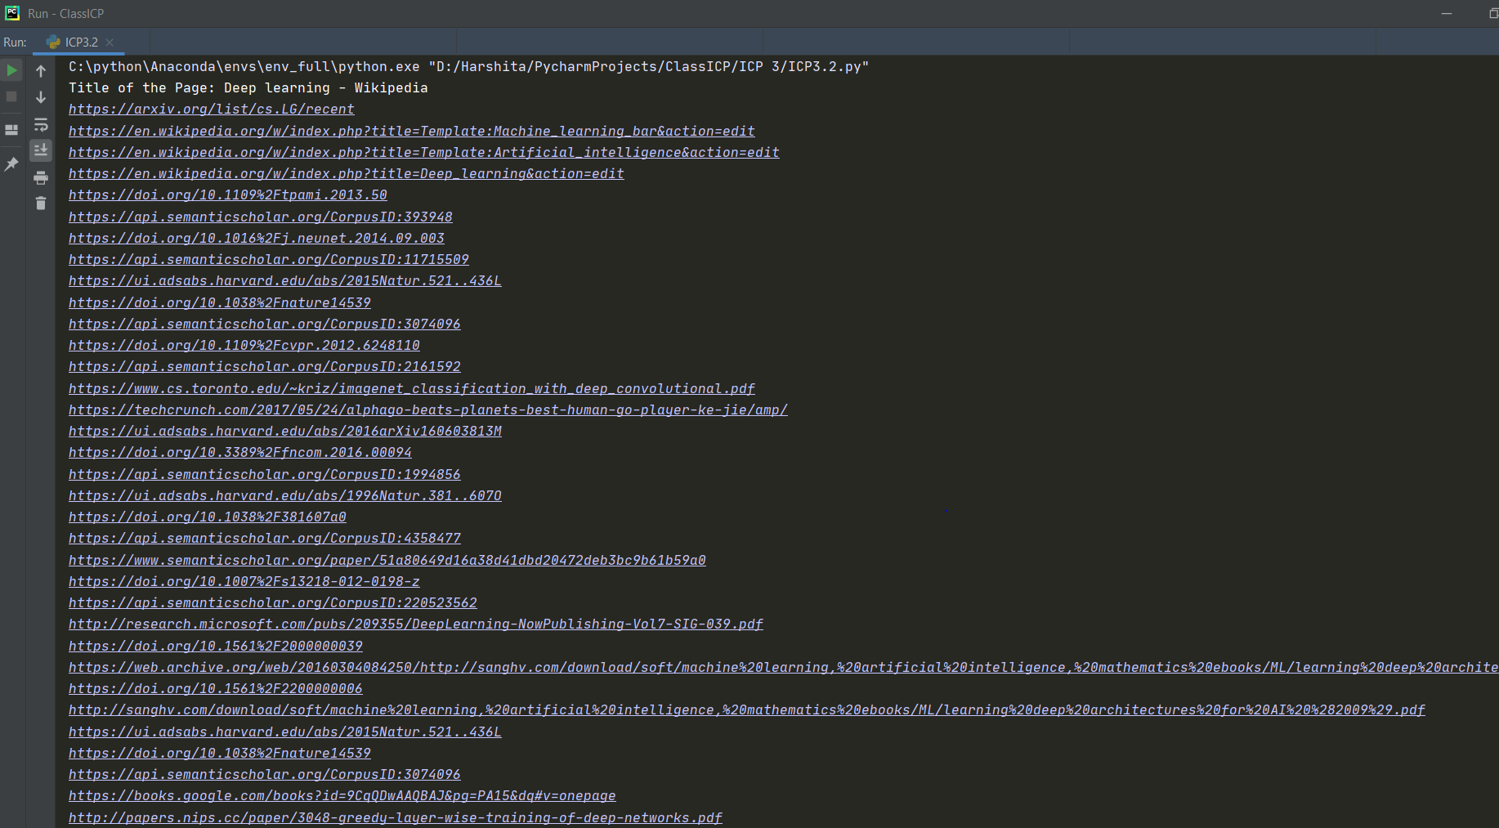

**Text File Output:**

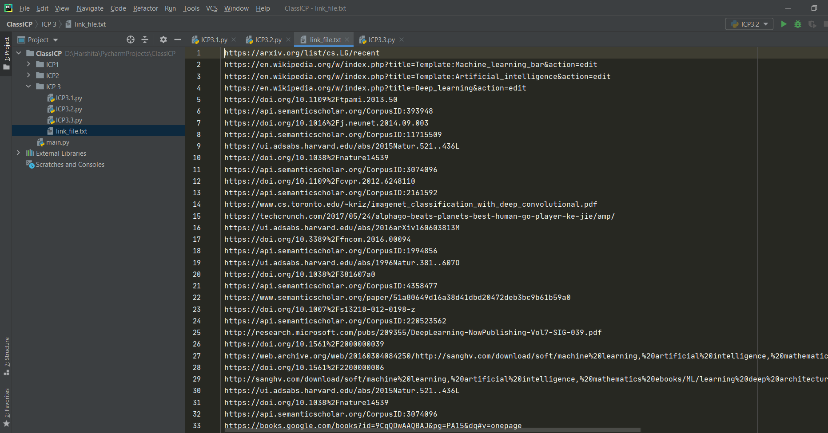

**Answer 3)**

**Code:**

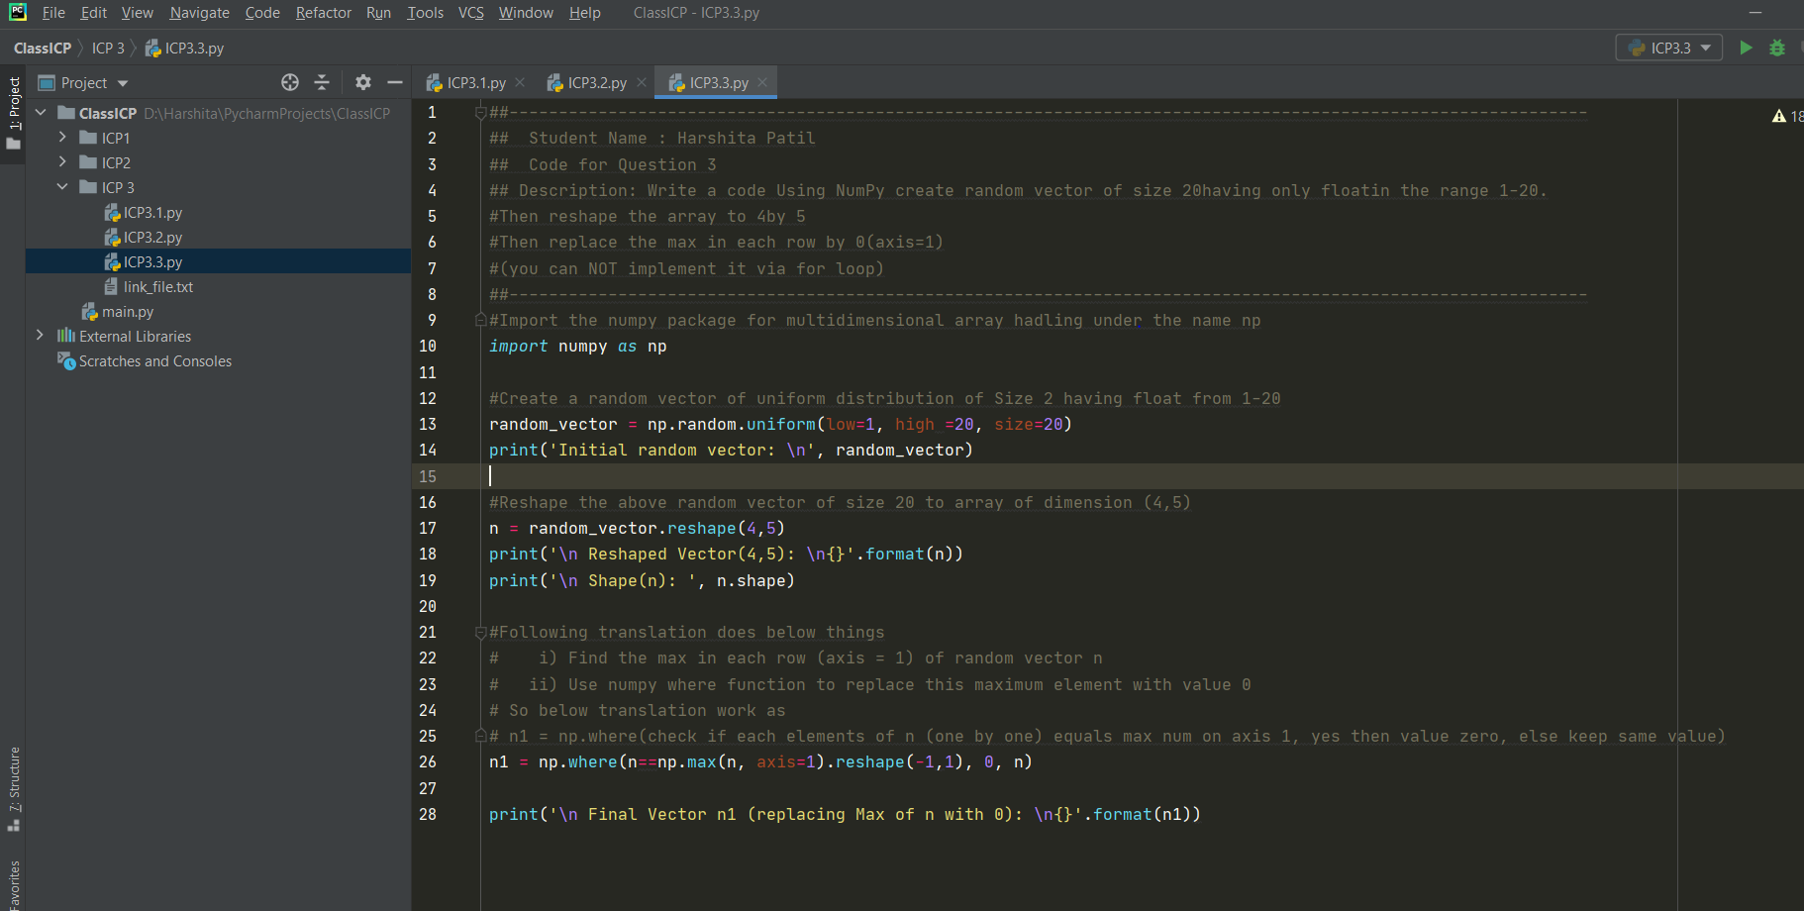

**OUTPUT: Output displays 1st random vector values, then values of vector after reshape and in the end values of vector after replacing max values in axis 1.**

